KenKen Puzzle

$$\left[intro\right]$$

$$It is a puzzle that easily understand but a brainy puzzle.$$

$$You can play it$$

$$even if you don^{'}t have to learn or know lots of$$

$$knowledge of math.$$

$$You just have to use the operation+,-,×,÷,$$

$$factorization of a number,some logic, pencils and papers$$

$$if you want to play it.$$

$$Its rule is very simple.$$

$$\left[rule\right]$$

$$For KenKen puzzle with n*n board.$$

$$1. In each block,only the number 1 to n is allowed.$$

$$2.In every row and column, the number 1 to n have to$$

$$appear exactly once.$$

$$The number 1 to n can NOT be repeated$$

$$in same row and column.$$

$$3.We define a cage as$$

$$a block or a group of blocks with a heavily black frame.$$

$$4.In each cage, the result value$$

$$for performing all operation must be equal to the$$

$$target value \left(which is displayed at top left of the cage\right).$$

$$For example,$$

$$in the following figure$$

$$R2C2*R3C2*R4C2 must be equal to 30.$$

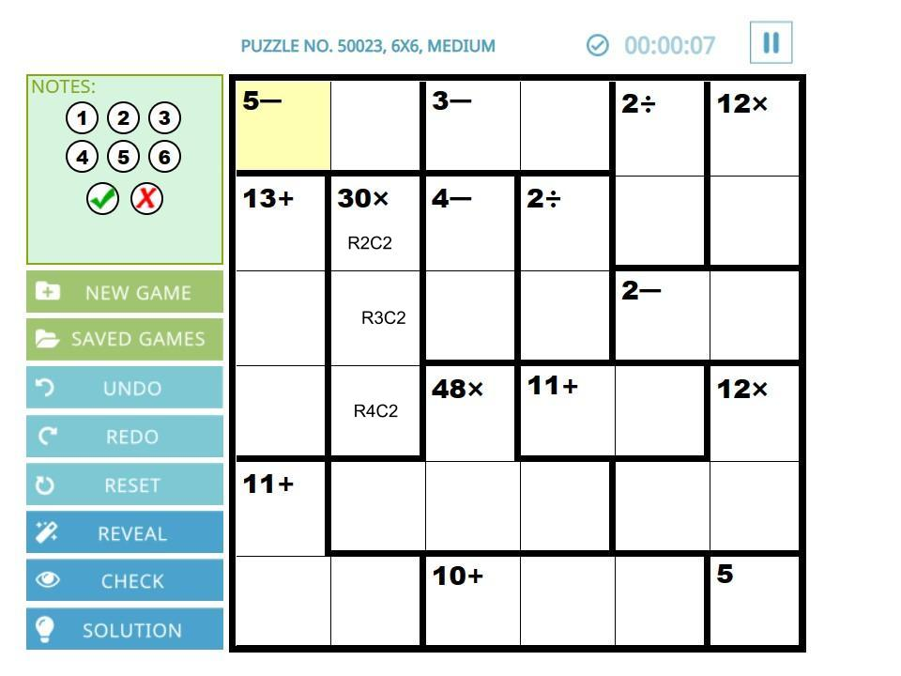

Ref:

To play KenKen puzzle.

[KenKen Puzzle Official Site - Free Math Puzzles That Make You Smarter!](https://www.kenkenpuzzle.com/)